
Lesson 5: Enemy Ranks
Scratch
VIDEO GAME CREATION
This week: one enemy becomes many. Your job is to turn last week's single enemy into a whole row of them, using a loop instead of repeating yourself by hand.
Open your own [YourName]Game project from Lesson 4 - don't start a new one. Everything this week builds on the enemy and collision detection you already have.
Tip: no new assets this week - you're reusing bullet_yellow.png, sfx_shoot.wav, enemy_invader_red.png, and sfx_hit.wav from your Lesson 3 and 4 Assets folders.

Setup
- Open your [YourName]Game project from Lesson 4.
- Switch to the Enemy sprite. Add a "for this sprite only" variable named enemy_x (right-click Variables > Make a Variable, choose "For this sprite only").
- Add a "when green flag clicked" script to the Enemy sprite with just "hide" - like Bullet, the original Enemy sprite should never be seen itself, only its clones.

Level 1 - Minimal (MVP)
Several enemies sit on screen in a row, created by a loop instead of placed or spawned one at a time. Shooting any one of them destroys just that one. This is a complete finish for today - reaching this is enough to move on to next week.
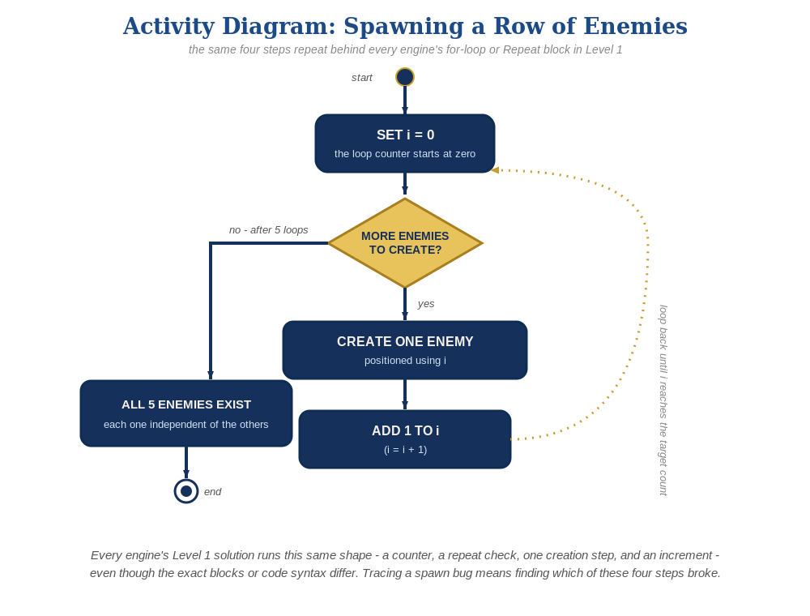
The spawn loop, in general - the same counter, repeat check, creation step, and increment behind Level 1 in every engine, whatever the exact blocks or syntax look like.
- Still on the Enemy sprite, build a spawn script: "when green flag clicked" (a second one, alongside the hide script) -> repeat 5 -> inside the loop, set enemy_x to a different value each time (e.g. using a counter variable, or (loop count * 100) - 300) -> create clone of myself.
- Add a "when I start as a clone" script to the Enemy: show, go to x: (enemy_x) y: 150.
- In that same clone script, add a forever loop containing "if <touching [Bullet]?> then delete this clone" - this replaces last week's Bullet-side check (see the note below for why).
- IMPORTANT: remove the touching-Enemy check from the Bullet sprite's own forever loop if you still have it from Lesson 4 - Bullet's script goes back to exactly what it was at the end of Lesson 3 (move up, clean up off-screen), nothing about enemies.
- Click the stage, then press spacebar aimed at different enemies to test - each one should disappear independently when hit.

Level 2 - Complete (Alpha/Beta)
Every enemy in the row can be individually shot and destroyed without affecting the others, and a bullet that misses every enemy still behaves exactly like it did last week.
- Shoot several different enemies in a row, including some misses - each hit should remove exactly the one enemy clone that was actually touched, and every other enemy should be unaffected.
- Note: Scratch clones don't have unique ID numbers the way objects do in other engines, so a Bullet clone can't identify exactly which Enemy clone it's touching from the Bullet's side. That's why the touching-check lives on the Enemy's own clone script instead - each Enemy clone only ever asks about itself, which works correctly no matter how many enemies or bullets are on screen.
- A hit bullet isn't explicitly deleted the instant it connects - it keeps moving upward and cleans itself up off-screen exactly like a miss would. This is a deliberate simplification, not a bug.

Level 3 - Refined (Ready to Publish) - pick any that interest you
- Sound: this already works with no changes - if you added "start sound [sfx_hit]" to the Enemy's clone script back in Lesson 4, every enemy clone plays it independently when hit.
- Visual: give enemies a striped look by alternating a costume or color effect based on their position in the loop (e.g., every other one gets "set color effect to 50"). Scratch's "color effect" isn't a literal red/green/blue color - it's a hue dial from 0 to 200 that cycles all the way around the color wheel. A value of 50 rotates about a quarter of the way around it, so on a red-ish enemy sprite the shifted enemies land somewhere around yellow-green, not on a specific named color - the goal is "visibly different," not a precise shade.
- Structure: keep the spawn loop's only job being creating clones and giving each one its starting position - the hit-detection and hide-on-hit logic stays entirely inside the "when I start as a clone" script, not the spawn script.

If Something's Wrong
- All enemies stack on top of each other: confirm enemy_x is actually being set to a new value before each "create clone of myself" - if it's set once outside the loop, every clone reads the same value.
- Shooting one enemy removes all of them, or none: confirm the touching check moved to the Enemy's own "when I start as a clone" script, not left on the Bullet - a leftover Bullet-side check will misbehave with multiple enemies.
- Project freezes: this almost always means a clone is creating another clone inside its own "when I start as a clone" script - the spawn loop belongs in its own separate green-flag script.

Want More?
Student Resource List > Scratch section, or scratch.mit.edu/ideas

